Assignment 3

Submitted by,

P.Mahalakshmi,

ECE

961819106035

**1.**Create a Bucket in IBM object:

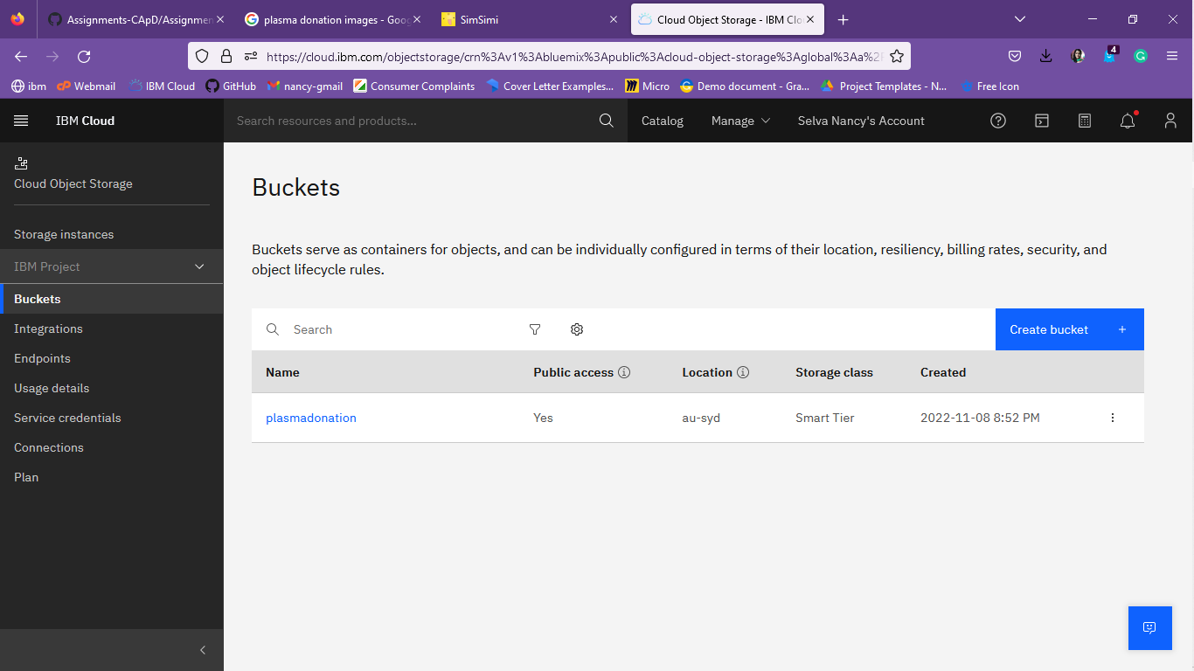

**2.** Upload 5 images to IBM object storage and make it public. Write html code to displaying all the 5 images**:**

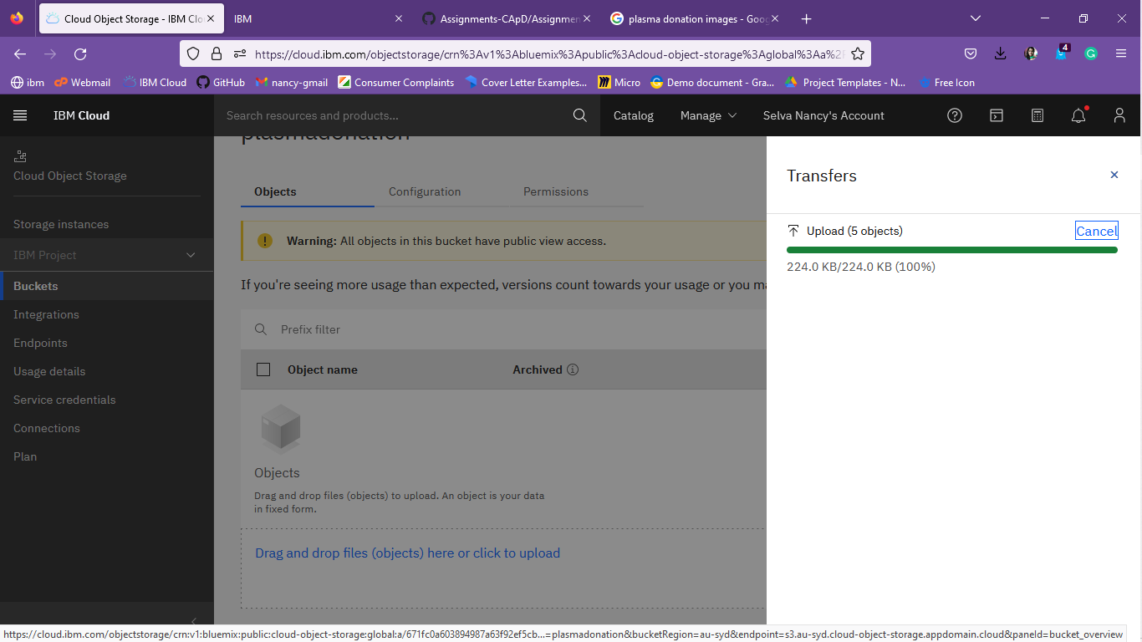

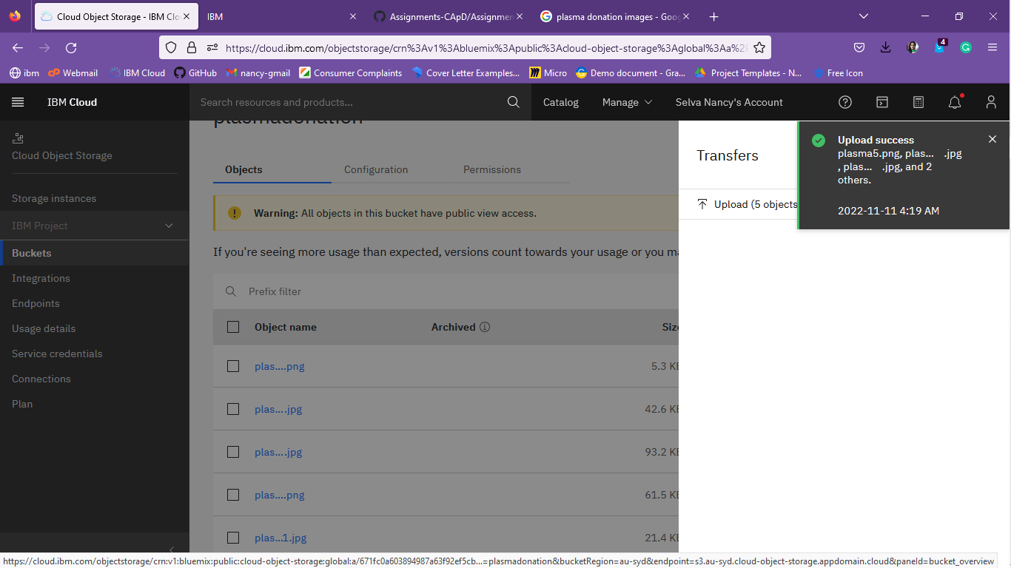

<!DOCTYPE html>

<html>

<head> <style> img {   width:250px;

  height:250px;

}

</style>

</head>

<body>

<img src="https://s3.jp-tok.cloud-object-storage.appdomain.cloud/plasmadonation/plasma1.png" alt="HTML5 Icon" >

<br>

<img src="https://s3.jp-tok.cloud-object-storage.appdomain.cloud/plasmadonation/plasma2.png" alt="HTML5 Icon">

<br>

<img src="https://s3.jp-tok.cloud-object-storage.appdomain.cloud/plasmadonation/plasma3.png" alt="HTML5 Icon" >

<br>

<img src="https://s3.jp-tok.cloud-object-storage.appdomain.cloud/plasmadonationplasma4.png" alt="HTML5 Icon">

<br>

<img src="https://s3.jp-tok.cloud-object-storage.appdomain.cloud/plasmadonation/plasma5.png" alt="HTML5 Icon">

<br>

</body>

</html>

**3.**Upload a CSS page to the object storage and use the same page in your HTML code:

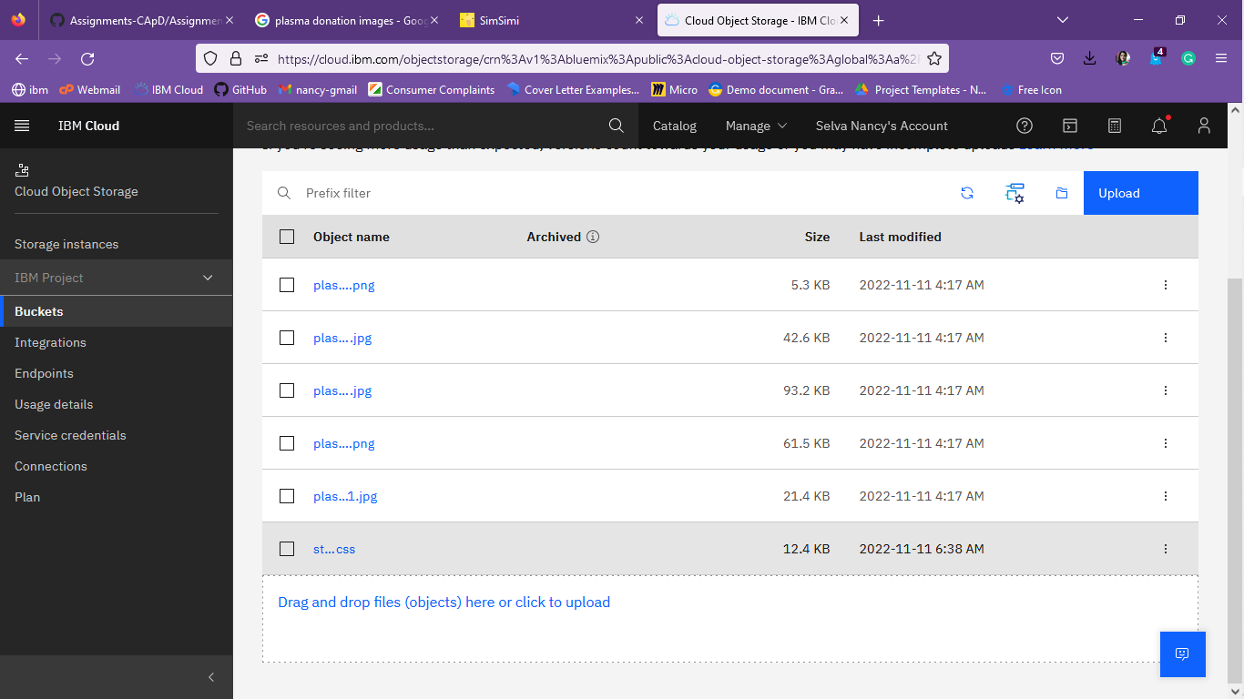

DOCTYPE html>

<html>

<head>

  <link rel="stylesheet" href="https://s3.jp-tok.cloud-object-storage.appdomain.cloud/plasmadonation/ styles.css">

</head>

<body>

<img src="https://s3.jp-tok.cloud-object-storage.appdomain.cloud/plasmadonation/plasma1.png" alt="HTML5 Icon" >

<br>

<img src="https://s3.jp-tok.cloud-object-storage.appdomain.cloud/plasmadonation/plasma2.png" alt="HTML5 Icon">

<br>

<img src="https://s3.jp-tok.cloud-object-storage.appdomain.cloud/plasmadonation/plasma3.png" alt="HTML5 Icon" >

<br>

<img src="https://s3.jp-tok.cloud-object-storage.appdomain.cloud/plasmadonation/plasma4.png" alt="HTML5 Icon">

<br>

<img src="https://s3.jp-tok.cloud-object-storage.appdomain.cloud/plasmadonation/plasma5.png" alt="HTML5 Icon">

<br>

</body>

</html>

4.Design a chatbot using IBM Watson assistant for hospital. Ex: User comes with query to know the branches for that hospital in your city. Submit the web URL of that chat bot as an assignment.

5.Create Watson assistant service with 10 steps and use 3 conditions in it. Load that script in HTML page.

**Solution:**

<!DOCTYPE html>

<html lang="en">

  <head>

    <meta charset="UTF-8" />

    <meta http-equiv="X-UA-Compatible" content="IE=edge" />

    <meta name="viewport" content="width=device-width, initial-scale=1.0" />     <title>IBM Object Storage Demo</title>

    <link

      rel="stylesheet"

      href="https:// mahaleninanushine-first-demo.s3.sng01.cloud-object-storage.appdomain.cloud/style.css"

    />

    <script>       window.watsonAssistantChatOptions = {         integrationID: "b8b38143-a95d-44b4-84f6-eef3ebb479f5", // The ID of this integration.         region: "au-syd", // The region your integration is hosted in.         serviceInstanceID: "d05024f0-2dbf-4ca1-9961-dc3402b37937", // The ID of your service instance.

        onLoad: function (instance) {           instance.render();

        },

      };

      setTimeout(function () {

        const t = document.createElement("script");

        t.src =

          "https://web-chat.global.assistant.watson.appdomain.cloud/versions/" +

          (window.watsonAssistantChatOptions.clientVersion || "latest") +

          "/WatsonAssistantChatEntry.js";         document.head.appendChild(t);

      });

    </script>

  </head>

  <body>

    <h1>Assignment 3</h1>

    <ol>

      <li>Create a Bucket in IBM object storage.</li>

      <li>

        Upload an 5 images to ibm object storage and make it public. write html         code to displaying all the 5 images.

      </li>

      <li>

        Upload a css page to the object storage and use the same page in your         HTML code.

      </li>

      <li>

        Design a chatbot using IBM Watson assistant for hospital. Ex: User comes         with query to know the branches for that hospital in your city. Submit         the web URL of that chat bot as a assignment.

      </li>

      <li>

        Create Watson assistant service with 10 steps and use 3 conditions in         it. Load that script in HTML page.

      </li>

    </ol>

    <div class="container">

      <img src="https://source.unsplash.com/random/900x700/?fruit[0]" alt="" />

      <img src="https://source.unsplash.com/random/900x700/?fruit[1]" alt="" />

      <img src="https://source.unsplash.com/random/900x700/?fruit[2]" alt="" />

      <img src="https://source.unsplash.com/random/900x700/?fruit[3]" alt="" />

      <img src="https://source.unsplash.com/random/900x700/?fruit[4]" alt="" />

    </div>

  </body>

</html>

**OUTPUT:**

https://mahaleninanushine-first-demo.s3.sng01.cloud-object-storage.appdomain.cloud/index.html

